

POLITEKNIK MALAYSIA

JABATAN TEKNOLOGI MAKLUMAT DAN KOMUNIKASI

MINI PROJECT 1
SESI I : 2025/2026

DFP40443 FULL STACK WEB DEVELOPMENT

TARIKH : MINGGU KE-6
MASA : 0 JAM (F2F) + 4 JAM (NF2F)

_______________________________________

Kertas soalan ini mengandungi enam (6) halaman bercetak.



DFP40443 FULL STACK WEB DEVELOPMENT

SESI 1 2026/2027

NO. | REGISTRATION NO | NAME
1 | 10DIT24F1251 | SRI SURYA A/L KUMARAN
2 | 10DIT24F1074 | MOHAMED AR RASYID BIN MOHAMED RIAS
3 | 10DIT24F181 | AIMAN SYAHMI BIN MUHAMMAD SHAHRIZAN
4 | 10DIT24F1237 | MUHAMMAD NAUFAL BIN NORAN

ASSESSMENT : MINI PROJECT 1

DEPARTMENT OF INFORMATION AND COMMUNICATION TECHNOLOGY | MINI PROJECT 1 SESSION: 2 2025/2026

COURSE CODE : DFP40443 | COURSE NAME : FULL STACK WEB DEVELOPMENT
Duration : 4 Hours(NF2F) | Total Marks ______/ 100
CLO 1 : Integrate PHP and MySQL with Bootstrap to build database-driven web applications projects (P4, PLO3)

INSTRUCTIONS:
- This assessment consists of TWO (2) main practical tasks designed to evaluate your proficiency in building database-driven web applications using PHP, MySQL, and the MVC architecture.
- You are required to submit your work in softcopy form, consisting of:
  - Source Code: A compressed folder (.zip) containing all project files (Model, View, Controller folders, CSS, and JS).
  - Database Export: A .sql file of your database schema.
  - Project Documentation: A technical report in PDF format.
- Read the questions carefully and refer to the attached RUBRIC for the marking scheme.
- PLAGIARISM WARNING: Marks will be strictly deducted, or a grade of zero may be awarded, if a student is found to be copying or sharing code from/to others. All logic and implementation must be your own work.

Scenario:

As a Full Stack Web Developer, you are required to develop a Web Based PSP Student Portal. For the front-end interface, you are encouraged to utilize the Bootstrap framework via CDN to design a responsive and user-friendly layout. The system should demonstrate the implementation of:
- MVC Architecture and modular coding
- Session management and Secure Coding Practices
- MySQL Database Integration and Database Relationships
- CRUD operations

PART 1: PROFILE MANAGEMENT & ACCOUNT SECURITY
In this section, you must ensure the system can handle students' personal information securely based on an active session

1.1 Student Profile Page
- Design: Create a profile page that displays the student's Name, NRIC, and Program.
- Session Management: The information displayed must be based strictly on the currently logged-in student using the $_SESSION variable.
- Access Control: The system must ensure that students cannot access or view the profile information of other students

1.2 Password Exchange Module
- Functionality: Build a password update feature containing input fields for: Old Password, New Password, and Confirm Password.
- Validation Logic: The system must verify the validity of the Old Password against the record in the database before allowing any changes.
- Data Security: Students are required to use Password Hashing techniques to process the new password before it is stored in the database.

PART 2: GRADE MANAGEMENT SYSTEM REVAMP
You are assigned to perform a revamp so that all student data is managed entirely through a MySQL database.

2.1 Dynamic database (MySQL)
• implement database access using SQL queries to retrieve student records.

2.2 Implementation of CRUD Operations
You are required to build the interface and logic for the following operations:
Operation | Technical Requirements
CREATE | Create a form to add new student records (Name, IC, and Marks) directly into the database.
READ | Display a complete list of students and their marks from the database in a table format.
UPDATE | Provide functionality to update existing student information or marks.
DELETE | Provide functionality to remove student records. Note: Ensure there is a confirmation prompt before data is permanently deleted.

TECHNICAL SPECIFICATIONS
- Architecture: The code must strictly follow the MVC pattern (Model, View,
Controller).
- Modular Coding: Use modular techniques such as include or require for reusable components like database connections.
- Security: Implement Prepared Statements for all SQL operations to prevent SQL Injection attacks.
- Validation: Include both client-side and server-side validation for all forms.

TABLE OF CONTENTS
- INTRODUCTION 1.1 Project Overview 1.2 Objectives 1.3 Technologies Used
- SYSTEM ARCHITECTURE & DESIGN 2.1 MVC Architecture Implementation 2.2 Database Schema Design 2.3 Security Measures
- PART 1: PROFILE MANAGEMENT & ACCOUNT SECURITY 3.1 Student Profile Page 3.2 Access Control Mechanism 3.3 Password Exchange Module
- PART 2: GRADE MANAGEMENT SYSTEM 4.1 Dynamic Database Integration 4.2 CRUD Operations Implementation 4.2.1 Create Student Record 4.2.2 Read Student List 4.2.3 Update Student Information 4.2.4 Delete Student Record
- TECHNICAL SPECIFICATIONS COMPLIANCE 5.1 Prepared Statements & SQL Injection Prevention 5.2 Client-Side & Server-Side Validation
- CONCLUSION

Introduction

The PSP Student Portal is a secure, database-driven web application developed to fulfill the requirements of DFP40443 Full Stack Web Development, designed to manage student profiles and academic records through a strict Model-View-Controller (MVC) architecture. Built using PHP 8.0, MySQL, and Bootstrap 4, this system integrates essential full-stack competencies including session-based access control, bcrypt password hashing for account security, and prepared statements to prevent SQL injection. The project addresses two core functional areas: a personalized Profile Management module that restricts data visibility to active sessions, and a comprehensive Grade Management System featuring complete CRUD operations with robust client-side and server-side validation.

1. System Architecture & Setup

Folder Structure:
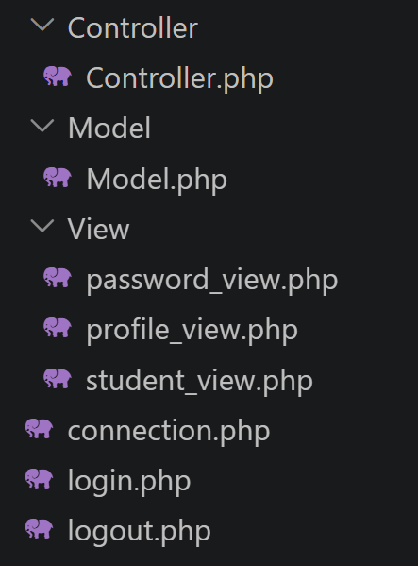

Database:
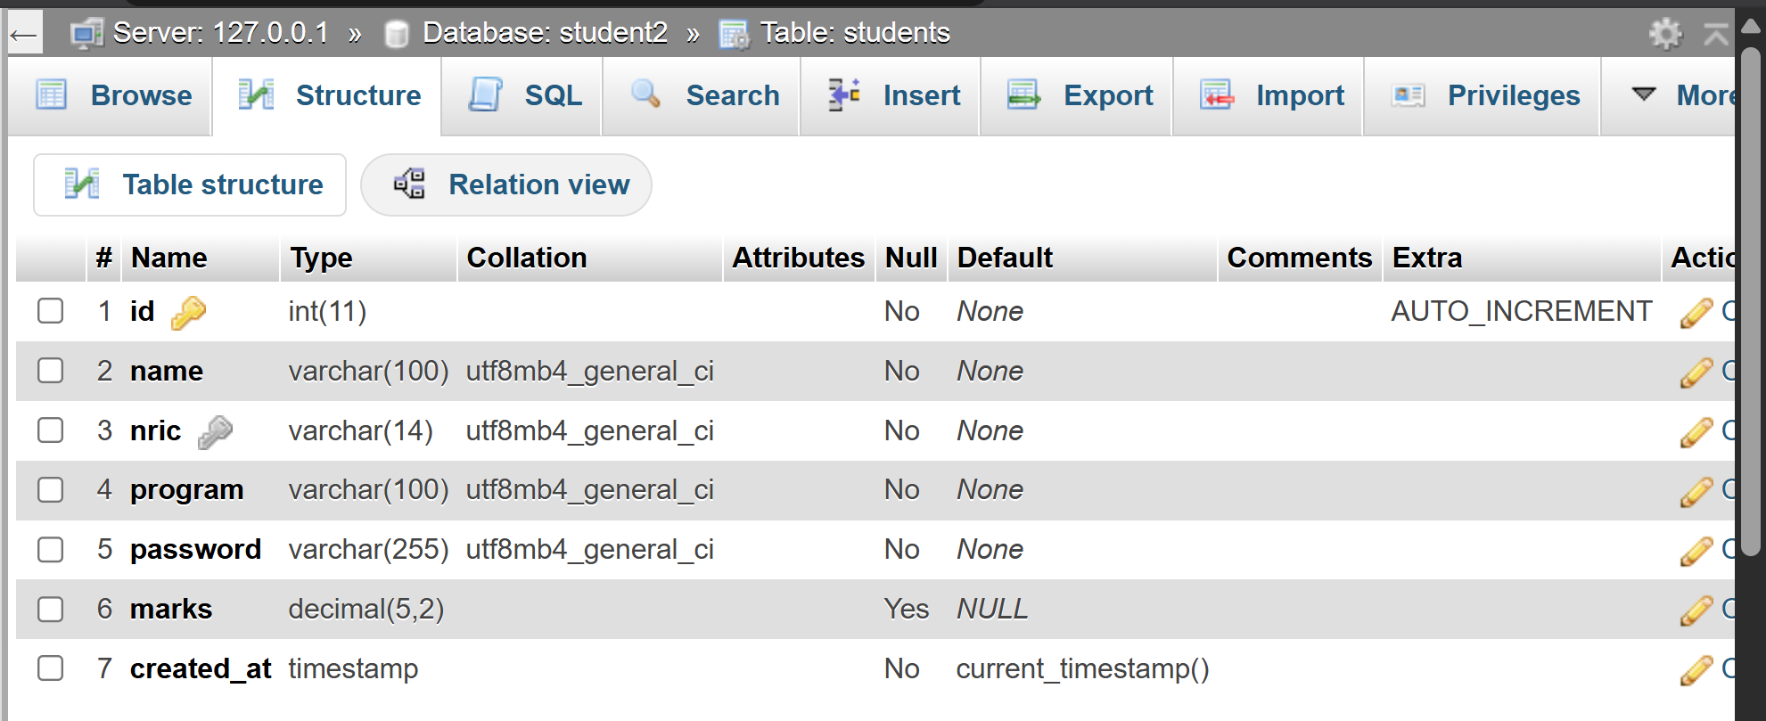
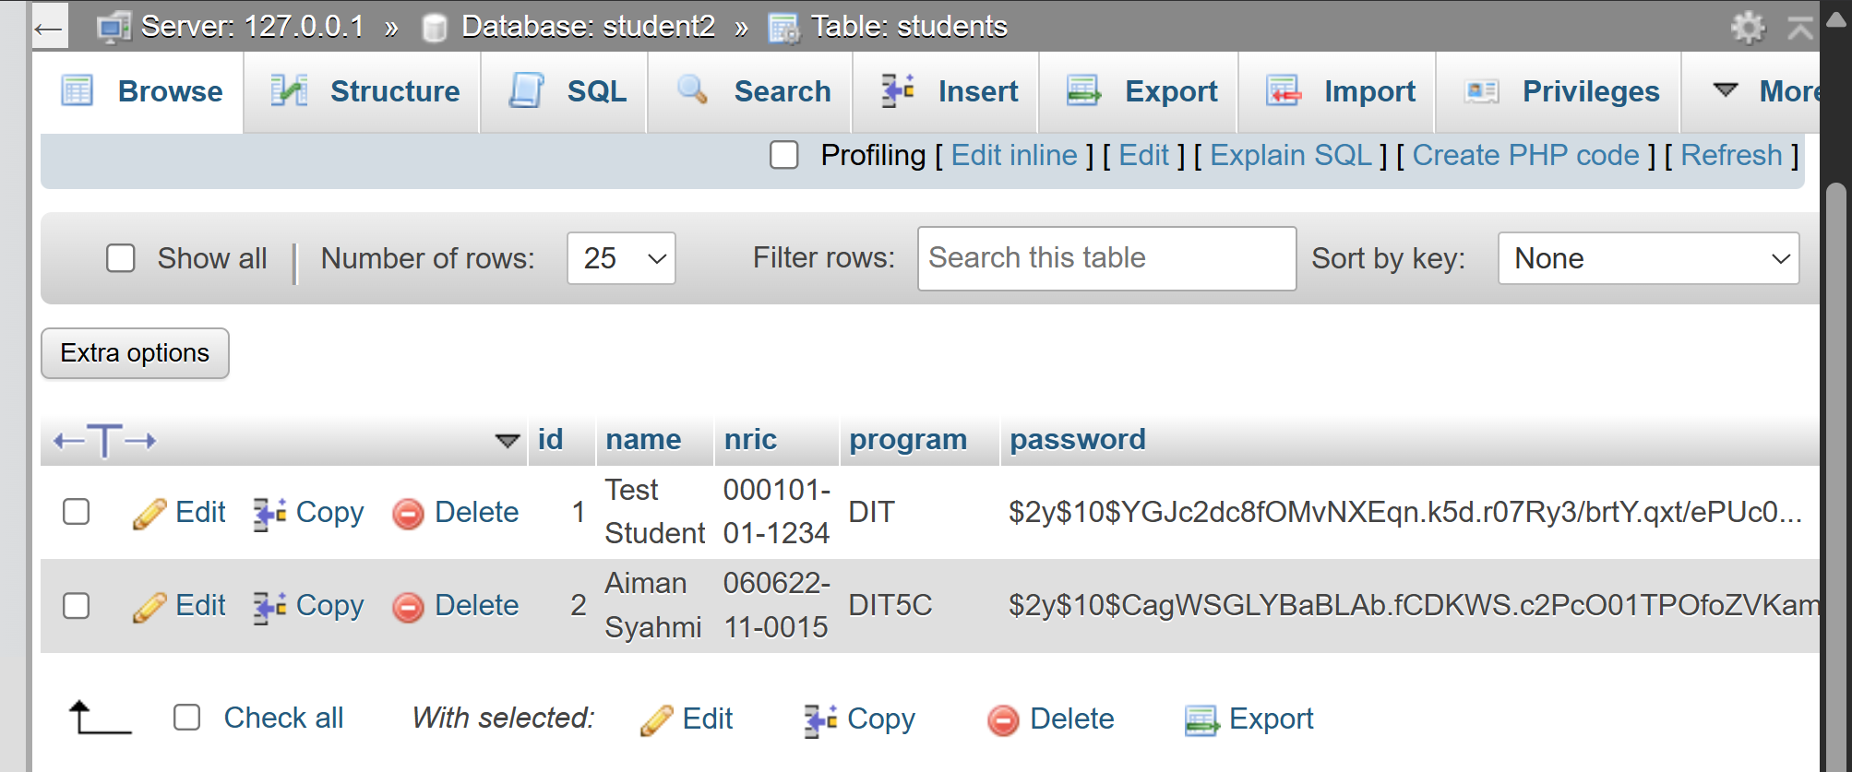
Connection Module:
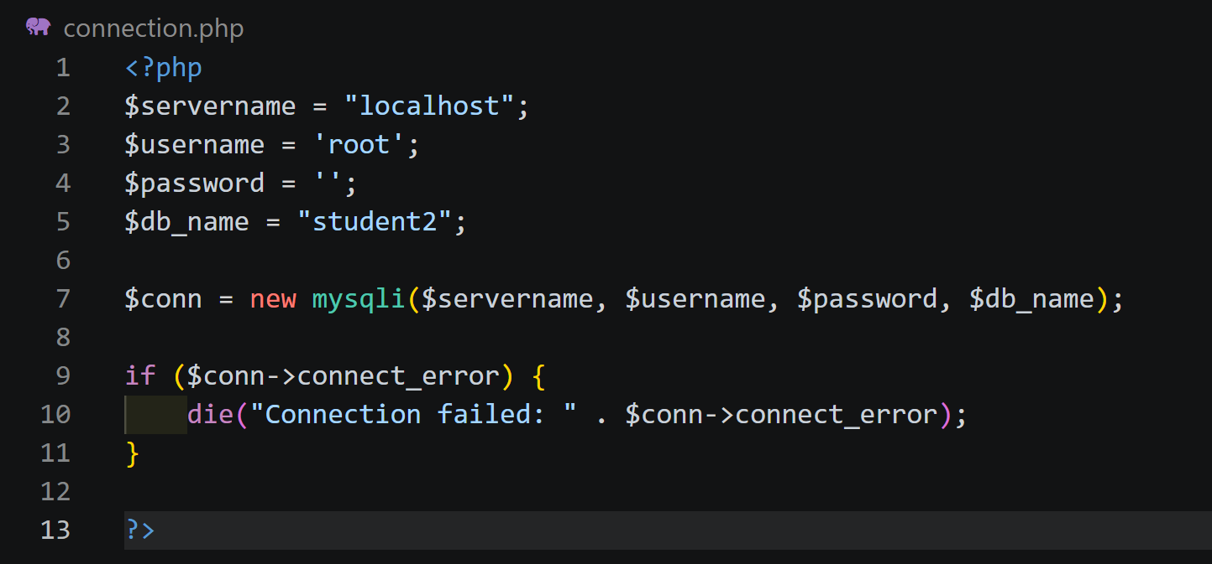

2. Part 1: Profile Management & Security

Login Page:
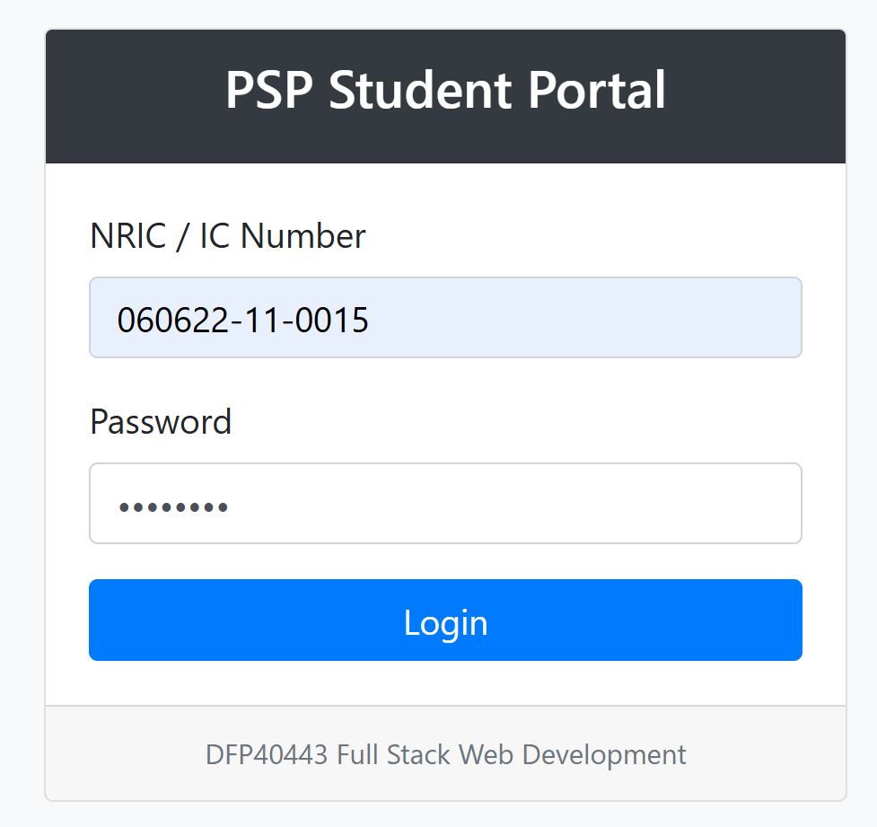

Access Control Test:
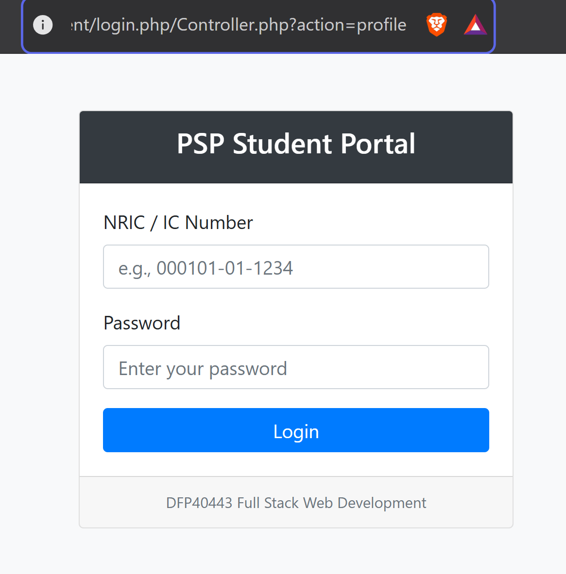
It will redirects back to login despite trying to bypass using action profile.

Password Change Form:
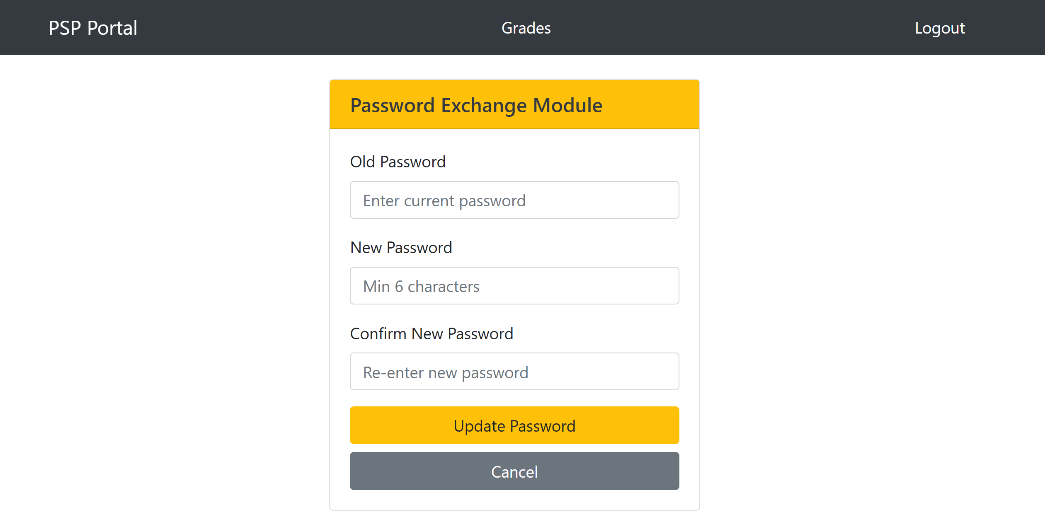

Password Hashing:
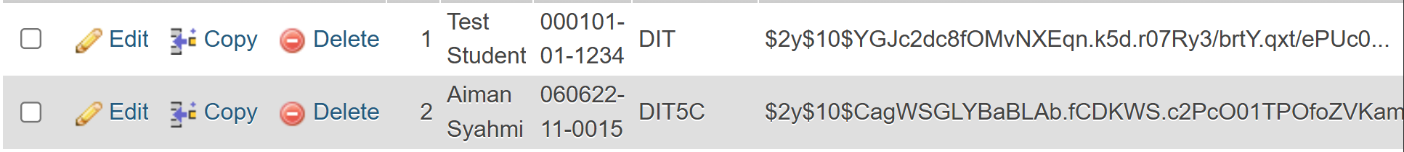

Part 2: Grade Management (CRUD)

READ (List View):
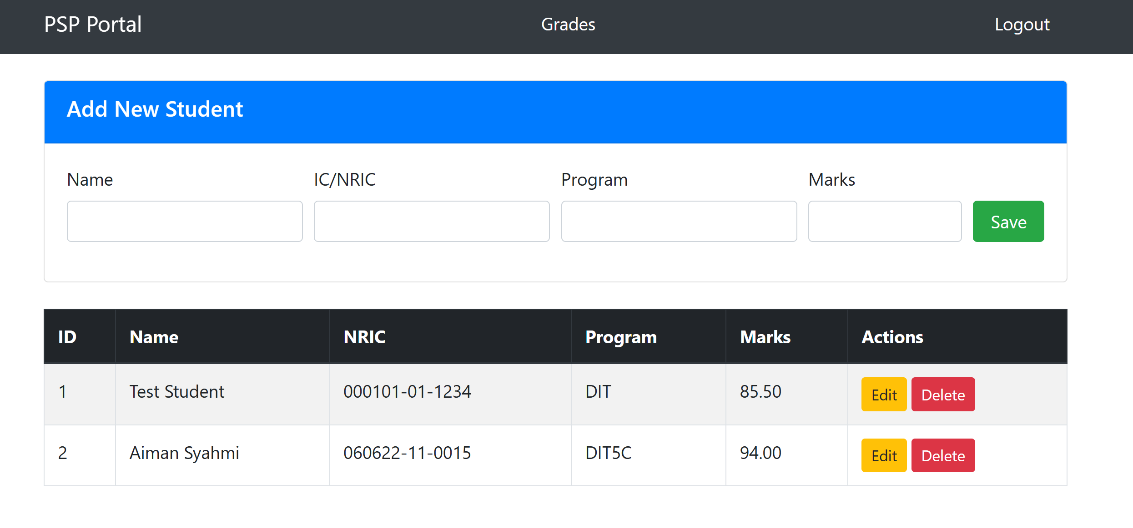

CREATE (Add Form):
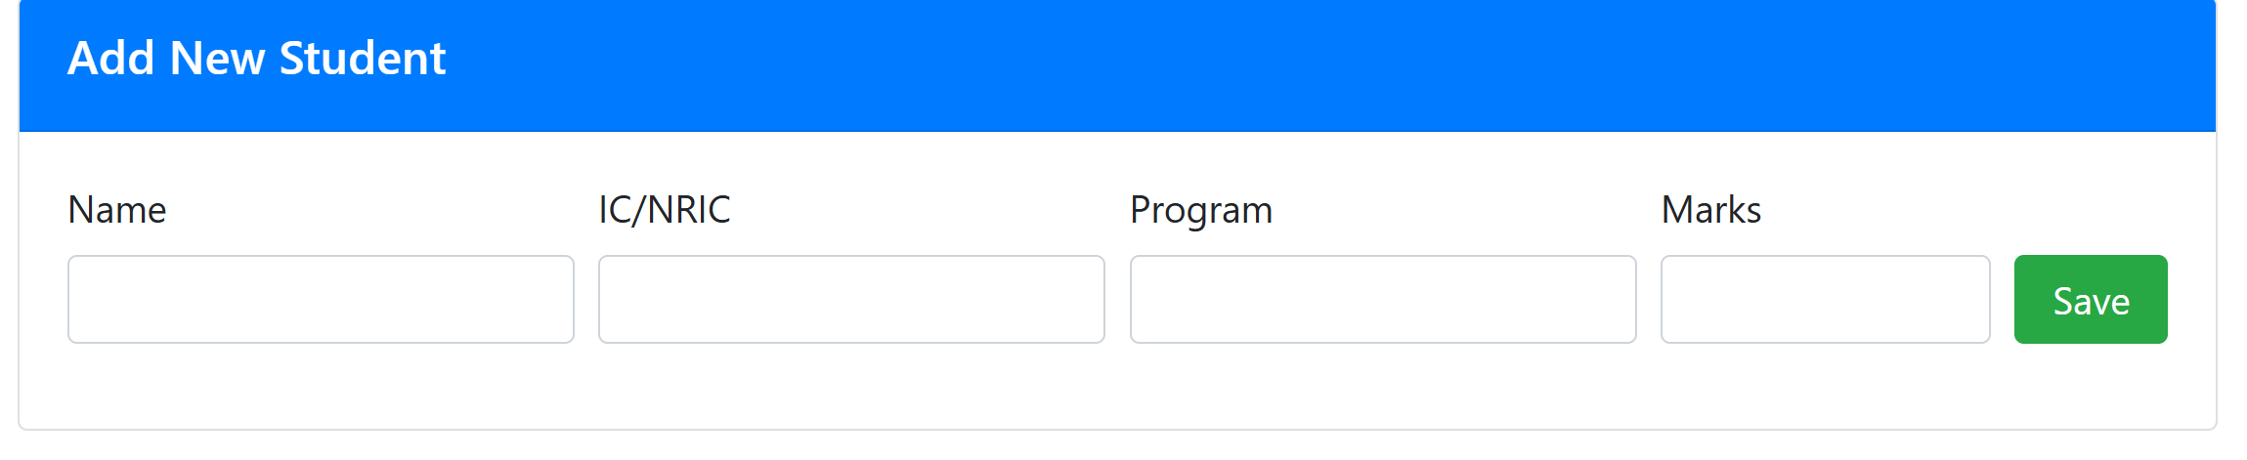

UPDATE (Edit Form):
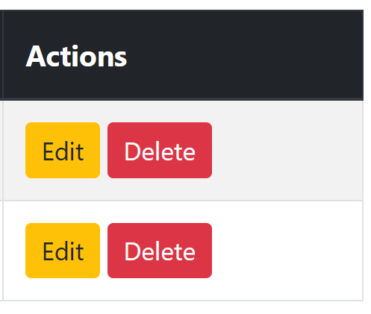

DELETE Confirmation:
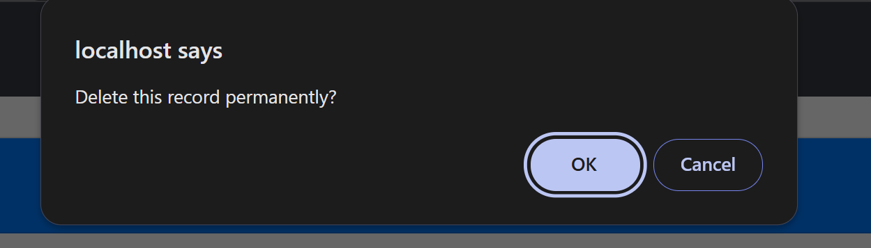
Validation & Error Handling

Client-Side Validation:
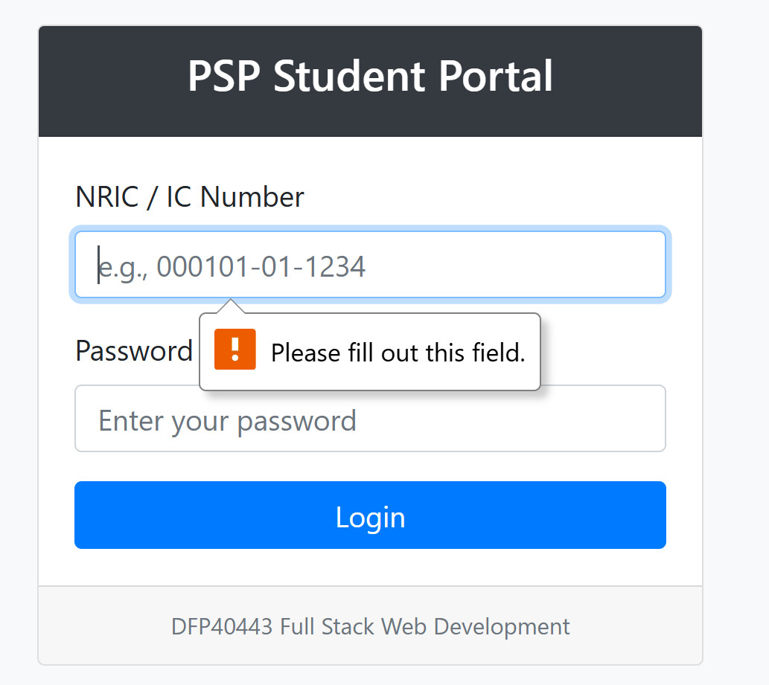

Server-Side Validation:
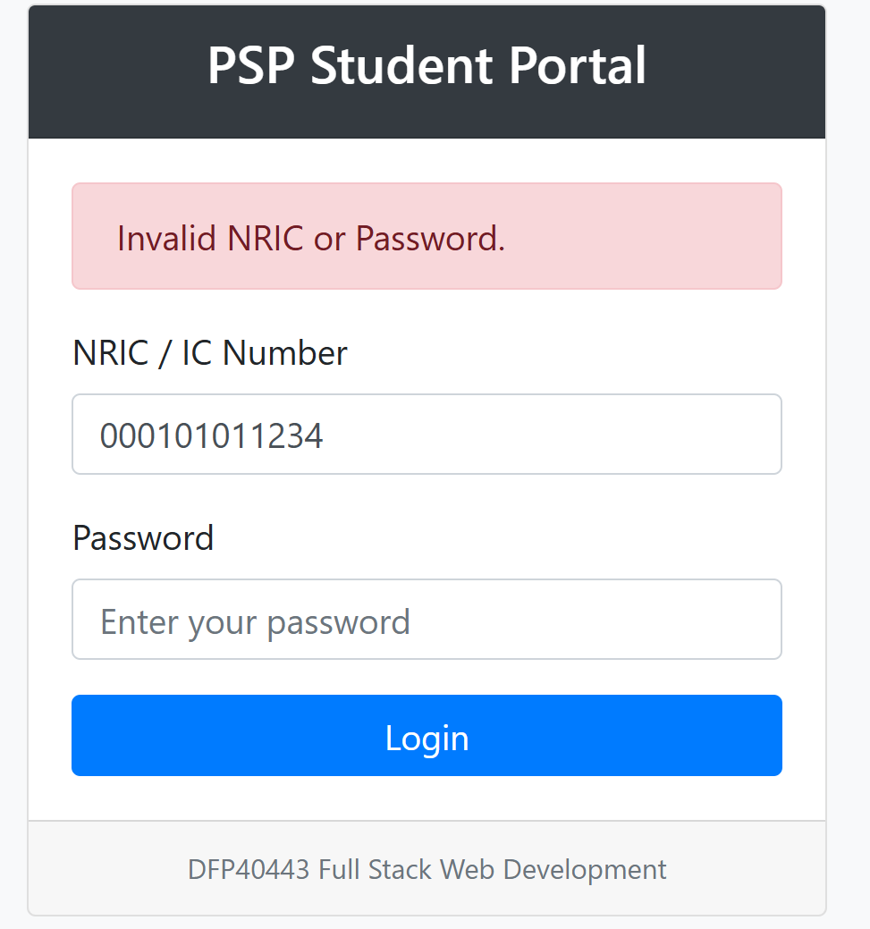

Source Code

login.php
<?php
error_reporting(E_ALL);
ini_set('display_errors', 1);
session_start();

// redirect when logged in
if (isset($_SESSION['student_id'])) {
header("Location: Controller/Controller.php?action=profile");
exit();
}

require_once 'connection.php';
require_once 'Model/Model.php';

$model = new StudentModel($conn);
$err = "";
$nric = "";

if ($_SERVER['REQUEST_METHOD'] === 'POST') {
$nric = trim($_POST['nric'] ?? '');
$password = $_POST['password'] ?? '';

if (empty($nric) || empty($password)) {
$err = "NRIC and Password are required.";
} else {

$stmt = $conn->prepare("SELECT id, password FROM students WHERE nric = ?");
$stmt->bind_param("s", $nric);
$stmt->execute();
$result = $stmt->get_result()->fetch_assoc();
$stmt->close();

// verify hashed password
if ($result && password_verify($password, $result['password'])) {
$_SESSION['student_id'] = $result['id'];
$_SESSION['student_nric'] = $nric;
header("Location: Controller/Controller.php?action=profile");
exit();
} else {
$err = "Invalid NRIC or Password.";
}
}
}
?>

<!DOCTYPE html>
<html lang="en">
<head>
<meta charset="UTF-8">
<title>PSP Student Portal - Login</title>
<link rel="stylesheet" href="https://maxcdn.bootstrapcdn.com/bootstrap/4.0.0/css/bootstrap.min.css"/>
</head>
<body class="bg-light">
<div class="container mt-5">
<div class="row justify-content-center">
<div class="col-md-5">
<div class="card shadow">
<div class="card-header bg-dark text-white text-center">
<h4>PSP Student Portal</h4>
</div>
<div class="card-body">
<?php if(!empty($err)): ?>
<div class="alert alert-danger"><?php echo htmlspecialchars($err); ?></div>
<?php endif; ?>

<form method="post">
<div class="form-group">
<label>NRIC / IC Number</label>
<input type="text" name="nric" class="form-control" required
placeholder="e.g., 000101-01-1234"
value="<?php echo htmlspecialchars($nric); ?>">
</div>
<div class="form-group">
<label>Password</label>
<input type="password" name="password" class="form-control" required
placeholder="Enter your password">
</div>
<button type="submit" class="btn btn-primary btn-block">Login</button>
</form>
</div>
<div class="card-footer text-center text-muted small">
DFP40443 Full Stack Web Development
</div>
</div>
</div>
</div>
</div>
</body>
</html>

logout.php

<?php

session_start();

$_SESSION = array();

if (ini_get("session.use_cookies")) {
$params = session_get_cookie_params();
setcookie(session_name(), '', time() - 42000,
$params["path"], $params["domain"],
$params["secure"], $params["httponly"]
);
}

session_destroy();

header("Location: login.php");
exit();
?>

connection.php

<?php
$servername = "localhost";
$username = 'root';
$password = '';
$db_name = "student2";

$conn = new mysqli($servername, $username, $password, $db_name);

if ($conn->connect_error) {
die("Connection failed: " . $conn->connect_error);
}

?>

Controller

Controller.php

<?php
$servername = "localhost";
$username = 'root';
$password = '';
$db_name = "student2";

$conn = new mysqli($servername, $username, $password, $db_name);

if ($conn->connect_error) {
die("Connection failed: " . $conn->connect_error);
}

?>

Model

Model.php

<?php
class StudentModel {
private $conn;

public function __construct($db_connection) {
$this->conn = $db_connection;
}

// PART 1.1: Profile for session user
public function getStudentById($id) {
$stmt = $this->conn->prepare("SELECT id, name, nric, program, marks FROM students WHERE id = ?");
$stmt->bind_param("i", $id);
$stmt->execute();
return $stmt->get_result()->fetch_assoc();
}

// PART 1.2: verify and pdate password
public function verifyPassword($id, $password) {
$stmt = $this->conn->prepare("SELECT password FROM students WHERE id = ?");
$stmt->bind_param("i", $id);
$stmt->execute();
$result = $stmt->get_result()->fetch_assoc();
return $result && password_verify($password, $result['password']);
}

public function updatePassword($id, $new_hashed_password) {
$stmt = $this->conn->prepare("UPDATE students SET password = ? WHERE id = ?");
$stmt->bind_param("si", $new_hashed_password, $id);
return $stmt->execute();
}

// PART 2.2: CRUD operations
public function getAllStudents() {
return $this->conn->query("SELECT * FROM students ORDER BY id ASC")->fetch_all(MYSQLI_ASSOC);
}

public function addStudent($name, $nric, $program, $marks, $password) {
$hash = password_hash($password, PASSWORD_DEFAULT);
$stmt = $this->conn->prepare("INSERT INTO students (name, nric, program, marks, password) VALUES (?, ?, ?, ?, ?)");
$stmt->bind_param("sssss", $name, $nric, $program, $marks, $hash);
return $stmt->execute();
}

public function updateStudent($id, $name, $nric, $program, $marks) {
$stmt = $this->conn->prepare("UPDATE students SET name=?, nric=?, program=?, marks=? WHERE id=?");
$stmt->bind_param("ssssi", $name, $nric, $program, $marks, $id);
return $stmt->execute();
}

public function deleteStudent($id) {
$stmt = $this->conn->prepare("DELETE FROM students WHERE id = ?");
$stmt->bind_param("i", $id);
return $stmt->execute();
}
}
?>

View

password_view.php

<!DOCTYPE html>
<html lang="en">
<head>
<meta charset="UTF-8">
<title>Change Password</title>
<link rel="stylesheet" href="https://maxcdn.bootstrapcdn.com/bootstrap/4.0.0/css/bootstrap.min.css"/>
</head>
<body>
<nav class="navbar navbar-dark bg-dark mb-4">
<div class="container">
<a class="navbar-brand" href="Controller.php?action=profile">PSP Portal</a>
<a class="nav-link text-white" href="Controller.php?action=manage">Grades</a>
<a class="nav-link text-white" href="../logout.php">Logout</a>
</div>
</nav>

<div class="container">
<div class="row justify-content-center">
<div class="col-md-5">
<div class="card shadow-sm">
<div class="card-header bg-warning text-dark">
<h5 class="mb-0">Password Exchange Module</h5>
</div>
<div class="card-body">
<?php if(isset($msg)): ?>
<div class="alert alert-success"><?php echo $msg; ?></div>
<?php endif; ?>

<?php if(isset($err)): ?>
<div class="alert alert-danger"><?php echo $err; ?></div>
<?php endif; ?>

<!-- PART 1.2: Password update form -->
<form method="post" action="Controller.php?action=change_password">
<div class="form-group">
<label>Old Password</label>
<input type="password" name="old_pass" class="form-control" required placeholder="Enter current password">
</div>

<div class="form-group">
<label>New Password</label>
<input type="password" name="new_pass" class="form-control" required minlength="6" placeholder="Min 6 characters">
</div>

<div class="form-group">
<label>Confirm New Password</label>
<input type="password" name="confirm_pass" class="form-control" required minlength="6" placeholder="Re-enter new password">
</div>

<button type="submit" class="btn btn-warning btn-block">Update Password</button>
<a href="Controller.php?action=profile" class="btn btn-secondary btn-block mt-2">Cancel</a>
</form>
</div>
</div>
</div>
</div>
</div>
</body>
</html>

profile_view.php

<!DOCTYPE html>
<html lang="en">
<head>
<meta charset="UTF-8">
<title>Change Password</title>
<link rel="stylesheet" href="https://maxcdn.bootstrapcdn.com/bootstrap/4.0.0/css/bootstrap.min.css"/>
</head>
<body>
<nav class="navbar navbar-dark bg-dark mb-4">
<div class="container">
<a class="navbar-brand" href="Controller.php?action=profile">PSP Portal</a>
<a class="nav-link text-white" href="Controller.php?action=manage">Grades</a>
<a class="nav-link text-white" href="../logout.php">Logout</a>
</div>
</nav>

<div class="container">
<div class="row justify-content-center">
<div class="col-md-5">
<div class="card shadow-sm">
<div class="card-header bg-warning text-dark">
<h5 class="mb-0">Password Exchange Module</h5>
</div>
<div class="card-body">
<?php if(isset($msg)): ?>
<div class="alert alert-success"><?php echo $msg; ?></div>
<?php endif; ?>

<?php if(isset($err)): ?>
<div class="alert alert-danger"><?php echo $err; ?></div>
<?php endif; ?>

<!-- PART 1.2: Password update form -->
<form method="post" action="Controller.php?action=change_password">
<div class="form-group">
<label>Old Password</label>
<input type="password" name="old_pass" class="form-control" required placeholder="Enter current password">
</div>

<div class="form-group">
<label>New Password</label>
<input type="password" name="new_pass" class="form-control" required minlength="6" placeholder="Min 6 characters">
</div>

<div class="form-group">
<label>Confirm New Password</label>
<input type="password" name="confirm_pass" class="form-control" required minlength="6" placeholder="Re-enter new password">
</div>

<button type="submit" class="btn btn-warning btn-block">Update Password</button>
<a href="Controller.php?action=profile" class="btn btn-secondary btn-block mt-2">Cancel</a>
</form>
</div>
</div>
</div>
</div>
</div>
</body>
</html>

student_view.php

<!DOCTYPE html>
<html lang="en">
<head>
<meta charset="UTF-8">
<title>Grade Management</title>
<link rel="stylesheet" href="https://maxcdn.bootstrapcdn.com/bootstrap/4.0.0/css/bootstrap.min.css"/>
</head>
<body>
<nav class="navbar navbar-dark bg-dark mb-4">
<div class="container">
<a class="navbar-brand" href="Controller.php?action=profile">PSP Portal</a>
<a class="nav-link text-white" href="Controller.php?action=manage">Grades</a>
<a class="nav-link text-white" href="../logout.php">Logout</a>
</div>
</nav>

<div class="container">
<!-- create and update formw -->
<div class="card mb-4">
<div class="card-header bg-primary text-white">
<h5><?php echo $editStudent ? 'Update Student' : 'Add New Student'; ?></h5>
</div>
<div class="card-body">
<form method="post">
<input type="hidden" name="id" value="<?php echo $editStudent['id'] ?? ''; ?>">
<div class="form-row">
<div class="form-group col-md-3"><label>Name</label><input type="text" name="name" class="form-control" required value="<?php echo $editStudent['name'] ?? ''; ?>"></div>
<div class="form-group col-md-3"><label>IC/NRIC</label><input type="text" name="ic" class="form-control" required value="<?php echo $editStudent['nric'] ?? ''; ?>"></div>
<div class="form-group col-md-3"><label>Program</label><input type="text" name="program" class="form-control" required value="<?php echo $editStudent['program'] ?? ''; ?>"></div>
<div class="form-group col-md-2"><label>Marks</label><input type="number" step="0.01" name="marks" class="form-control" required value="<?php echo $editStudent['marks'] ?? ''; ?>"></div>
<div class="form-group col-md-1 d-flex align-items-end"><button type="submit" name="save" class="btn btn-success btn-block">Save</button></div>
</div>
</form>
</div>
</div>

<!-- table -->
<table class="table table-bordered table-striped">
<thead class="thead-dark"><tr><th>ID</th><th>Name</th><th>NRIC</th><th>Program</th><th>Marks</th><th>Actions</th></tr></thead>
<tbody>
<?php foreach ($students as $s): ?>
<tr>
<td><?php echo $s['id']; ?></td>
<td><?php echo htmlspecialchars($s['name']); ?></td>
<td><?php echo htmlspecialchars($s['nric']); ?></td>
<td><?php echo htmlspecialchars($s['program']); ?></td>
<td><?php echo $s['marks']; ?></td>
<td>
<a href="Controller.php?action=manage&edit=<?php echo $s['id']; ?>" class="btn btn-sm btn-warning">Edit</a>
<form method="post" style="display:inline;" onsubmit="return confirm('Delete this record permanently?');">
<input type="hidden" name="id" value="<?php echo $s['id']; ?>">
<button type="submit" name="delete" class="btn btn-sm btn-danger">Delete</button>
</form>
</td>
</tr>
<?php endforeach; ?>
</tbody>
</table>
</div>
</body>
</html>

Conclusion

The successful implementation of the PSP Student Portal demonstrates full compliance with the DFP40443 Mini Project 1 integrating PHP and MySQL using a modular MVC framework to build a secure and responsive web application. Making sure a strict session management then implementing password hashing through password_verify(), and utilizing prepared statements for all database interactions. Twhe system satisfies both functional requirements and critical technical specifications for a secure coding practices. This project not only validates proficiency in dynamic database integration and CRUD operations but also establishes a scalable foundation for future enhancements such as role-based access control and automated reporting for an industry-standard full-stack development methodologies.



